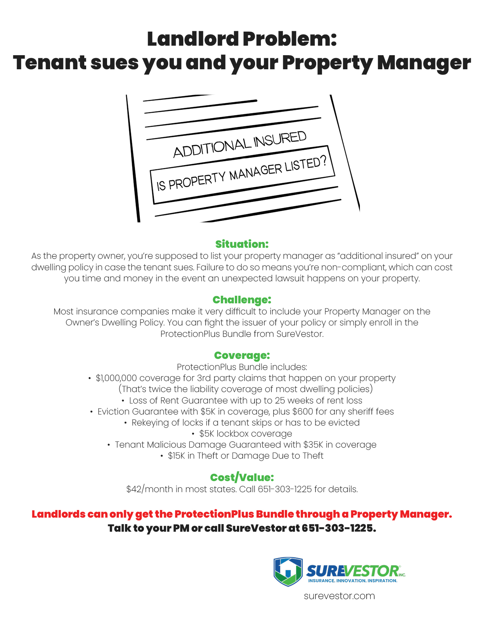

**Property Manager’s name, contact information and logo should go in this area.**