

[info@surevestor.com](mailto:info@surevestor.com)

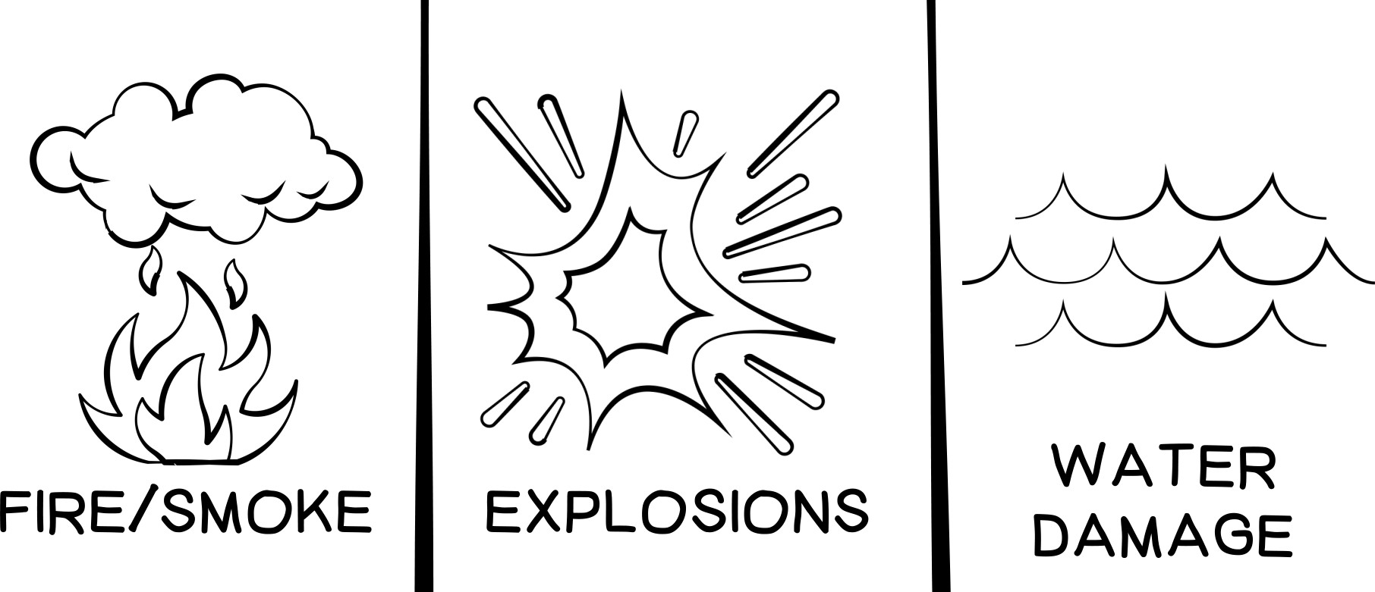

Landlord Problem:

Accidental Tenant Damage

# SITUATION:

Tenant accidentally causes expensive damage to property from fire, smoke, explosions, falling objects, and water damage from overflow, discharge or leakage.

# CHALLENGE:

Tenant may have insurance that covers expenses, but they often don’t, or let their policy lapse. Your dwelling policy should cover it, but then you have to pay the deductible and chase the tenant to get reimbursed.

Plus, each claim may result in your premiums going up.



**SOLUTION:**

**Master Tenant Liability**

**COVERAGE:**

* $100,000 coverage for fire, smoke, explosions, falling objects, and water damage from overflow, discharge or leakage - per occurence
  + No cost to landlord. Low cost to tenant
* Ensures 100% compliance among tenants
* Protects landlords against claims to homeowner’s policy
* Prevents insurance companies raising premiums due to damage claims

**Landlords can only get the Master Tenant Liability through a Property Manager Talk to your Property Manager or call SureVestor at 651-303-1225**

[](http://surevestor.com/)