

[info@surevestor.com](mailto:info@surevestor.com)

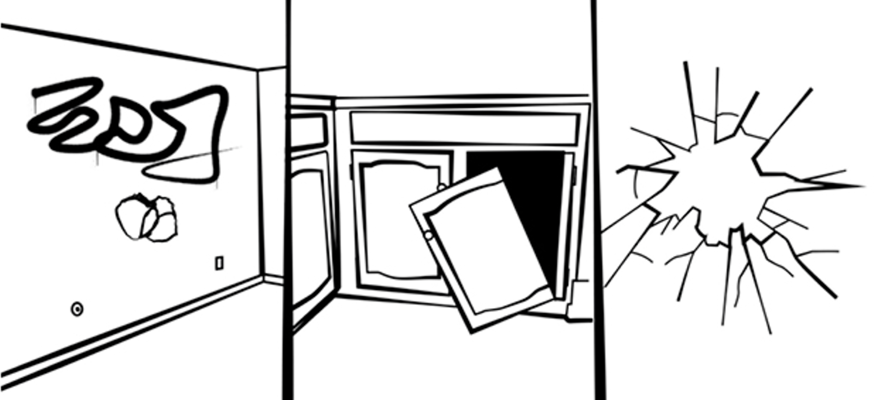

**SITUATION:**

Landlord Problem:

Tenant Malicious Damage

Angry tenant creates intentional damage to your property,

such as putting holes in walls, breaking windows, spray-painting graffiti, etc.

CHALLENGE:

There’s not an insurance company in the U.S. that covers Tenant Malicious Damage

...except for SureVestor. You’ll have to sue your tenant... and good luck collecting on that!



**SOLUTION:**

**Enroll in the affordable ProtectionPlus Bundle from**

**COVERAGE:**

* Tenant Malicious Damage **GUARANTEE** with $35,000 in coverage
  + Loss of Rent **GUARANTEE** with up to 25 weeks of rent loss
* Eviction **GUARANTEE** with $5,000 in coverage, plus $600 for any sheriff fees
  + $1,000,000 coverage for 3rd Party Claims that happen on your property (That’s **TWICE** the liability coverage of most dwelling policies)
    - $15,000 in Theft or Damage Due to Theft
* Rekeying of locks if a tenant skips or has to be evicted
  + $5,000 lockbox coverage

Landlords can only get the ProtectionPlus Bundle through a Property Manager Talk to your Property Manager or call SureVestor at 651-303-1225

[](http://surevestor.com/)