

[info@surevestor.com](mailto:info@surevestor.com)

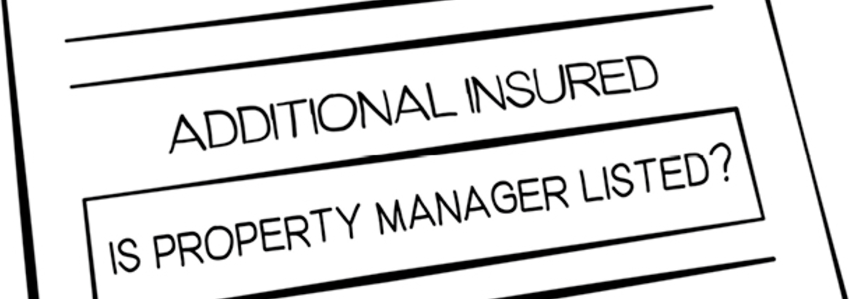

Property Manager

Landlord Problem:

Tenant Sues you and your

# SITUATION:

As the property owner, you’re supposed to list your property manager as “additional insured” on your dwelling policy in case the tenant sues. Failure to do so means you’re non-compliant, which can

cost you time and money in the event an unexpected lawsuit happens on your property.

# CHALLENGE:

Most insurance companies make it very difficult to include your Property Manager on the Owner’s Dwelling Policy and won’t do it without a fight.



**SOLUTION:**

**Enroll in the affordable ProtectionPlus Bundle from**

**COVERAGE:**

* $1,000,000 coverage for 3rd Party Claims that happen on your property (That’s **TWICE** the liability coverage of most dwelling policies)
  + Loss of Rent **GUARANTEE** with up to 25 weeks of rent loss
* Eviction **GUARANTEE** with $5,000 in coverage, plus $600 for any sheriff fees
  + Rekeying of locks if a tenant skips or has to be evicted
    - $5,000 lockbox coverage
* Tenant Malicious Damage **GUARANTEE** with $35,000 in coverage
  + $15,000 in Theft or Damage Due to Theft

**Landlords can only get the ProtectionPlus Bundle through a Property Manager Talk to your Property Manager or call SureVestor at 651-303-1225**

[](http://surevestor.com/)